**Design Proposal for the Garbage Classification System**

**Project Title**: Design of a Garbage Classification System based on Cell Phone Photos Description.

**Group Members**: Tianhan Jiang, Peiyun Zhao, David Laditan, David Guo, Tobi Lawal

**Contact Email**: [yuhua.guo@ucalgary.ca](mailto:yuhua.guo@ucalgary.ca), [tianhan.jiang@ucalgary.ca](mailto:tianhan.jiang@ucalgary.ca), [peizhao@ucalgary.ca](mailto:peizhao@ucalgary.ca), [oluwapelumi.laditan@ucalgary.ca](mailto:oluwapelumi.laditan@ucalgary.ca) and [tobi.lawal1@ucalgary.ca](mailto:tobi.lawal1@ucalgary.ca)

**Project Abstract**

Waste sorting is part of Calgary's waste management requirement of households to complete their recycling process. This task is usually labor intensive, and the risk of illness such as infections of the skin, respiratory system, and gastrointestinal tract is much higher. More so, manual pipeline sorting of waste used in processing plants has a disadvantage of human exposure to Calgary’s harsh weather conditions and low sorting efficiency. In order to solve various problems in garbage classification and recycling and to make the whole process more efficient and save resources, we propose a garbage classification management system using CNN-based networks.

1. **System Specifications**
   1. Approaches

Garbage recognition is a supervised learning task. We will use deep learning libraries to perform a multiclass classification job on an image dataset. We plan to label images to build a single-labelled training. Although the accuracy may improve if we train our model on a multi-labelled training set, we may face much more uncertainties and difficulties if we do so.

* 1. Models to be used

We plan to train and fine-tune multiple convolutional neural network (CNN)-based networks, including pre-trained on the ImageNet database and trained from scratch. Some articles[1] suggested that a pre-trained CNN model may perform better, but for our case, it may not apply well because of the difference in labelling rules.

Since the size of the dataset we will use is relatively small, we plan to use data augmentation[2] and explicit regularization, including dropout and weight decay, to avoid overfitting[4].

* 1. Metrics to be computed

Since this is a classification job, the most critical metric to tune hyperparameters and to represent training/validation score is accuracy. We will still record other classification metrics[3] such as accuracy, precision, recall, F1-score and AUC-ROC.

We will use Categorical Cross Entropy (CCE) as a metric in the loss function. We will monitor both training loss and validation loss.

* 1. Problems expected to face

About image

* Cell-phone photos have different quality depending on the device used to take the picture.
* Images with different resolutions.
* Model generalization to photos taken using different cell phones will be hard.

About subjectivity in labelling dataset

* What degree of contamination is acceptable for recyclable and for composting.

About limitations of the training set

* Misclassification of hazardous waste into black bin, due to lack of hazardous waste class.
* Too much variability within classes.
* Misclassifications caused by differences in packaging, shape, or graphic design.

1. **Dataset Creation**

In recent years, the dataset used toward training our neural network methods for image classification has increasingly improved overtime. With this in mind, several datasets like the CIFAR-10, MNIST handwritten numerals, are available and have recorded good results with models[5].  However, to achieve an accurate classification of garbage types for Calgary waste management system, we have decided to curate our dataset from mobile phone pictures of typical garbage disposed of in Calgary households. Our dataset will comprise 150 photos of garbage, with each image centered on a white background. The distribution is shown in Table 1 below. The type of garbage-images used also are spread evenly across the different garbage classes (blue, green, black trash bins).  We plan on implementing data augmentation of the dataset because of its small size and this invariably will improve the metrics of the model.

**Conclusion**

From the lecture and literature review, we have gained some understanding of the classification accuracy of CNN-based models. Currently, we are expecting that the network we are about to build in assignment 5 will effectively classify most garbage images in the dataset. However, we are also facing many difficulties due to various uncertainties (e.g., quality of the combined dataset, quality of labelling, and inadequate training set volume).

**Figures and Tables**

TABLE 1. There are six categories of the dataset with 150 pictures. There are few classes in this dataset, and the amount of data is small. Data enhancement will be performed to avoid overfitting of the model[6].

|  |  |  |  |  |  |  |
| --- | --- | --- | --- | --- | --- | --- |
| Blue: |  |  | Black: |  | Green: |  |
| Bottle | Paper | Other | Packaging | Miscellaneous | Food | Other |
| 26 | 16 | 8 | 27 | 28 | 34 | 11 |
| total: |  | 50 | total: | 55 | total: | 45 |

Figure 1. Pie chart of waste categories

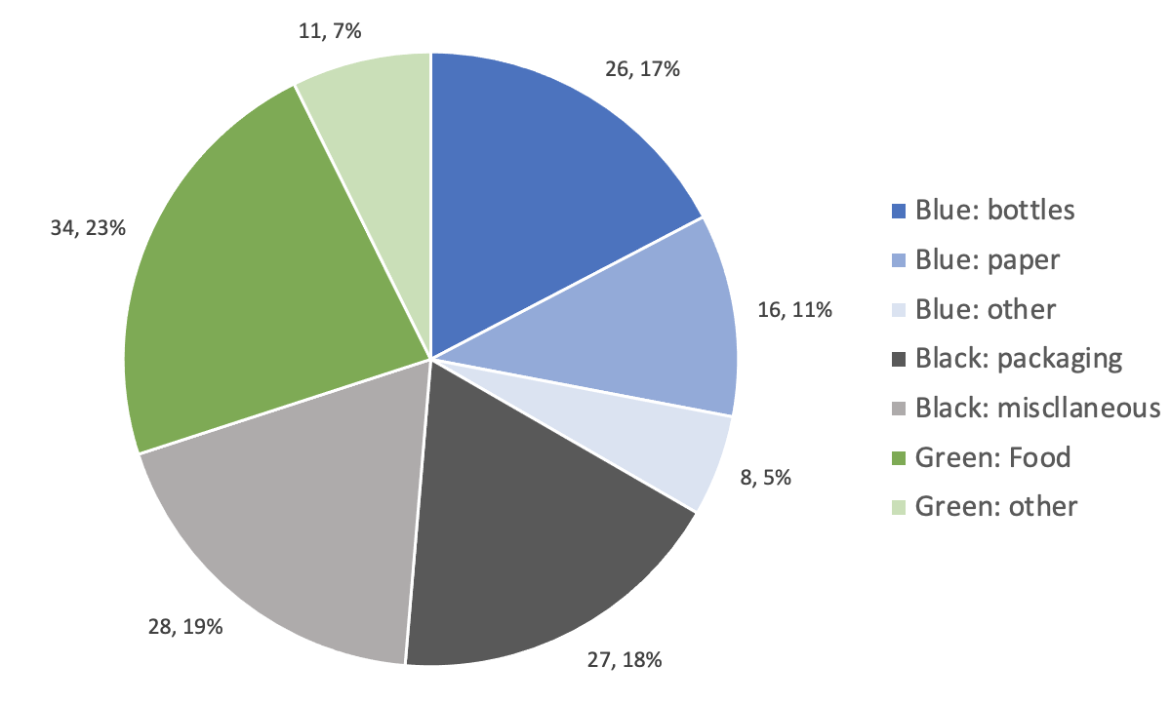

**Reference**

[1] How to build an image classifier for waste sorting. <https://towardsdatascience.com/how-to-build-an-image-classifier-for-waste-sorting-6d11d3c9c478>

[2] Shorten, C., Khoshgoftaar, T.M. A survey on Image Data Augmentation for Deep Learning. J Big Data 6, 60 (2019). <https://doi.org/10.1186/s40537-019-0197-0>

[3] The 5 Classification Evaluation metrics every Data Scientist must know

<https://towardsdatascience.com/the-5-classification-evaluation-metrics-you-must-know-aa97784ff226>

[4] Yinghao Chu, Chen Huang, Xiaodan Xie, Bohai Tan, Shyam Kamal, Xiaogang Xiong, Multilayer Hybrid Deep-Learning Method for Waste Classification and Recycling, Computational Intelligence and Neuroscience, vol. 2018, Article ID 5060857, 9 pages, 2018. <https://doi.org/10.1155/2018/5060857>

[5] G. E. Sakr, M. Mokbel, A. Darwich, M. N. Khneisser and A. Hadi, Comparing deep learning and support vector machines for autonomous waste sorting, 2016 IEEE International Multidisciplinary Conference on Engineering Technology (IMCET), Beirut, 2016, pp. 207-212, doi: 10.1109/IMCET.2016.7777453.

[6] K. Ahmad, K. Khan and A. Al-Fuqaha, "Intelligent Fusion of Deep Features for Improved Waste Classification," in IEEE Access, vol. 8, pp. 96495-96504, 2020, doi: 10.1109/ACCESS.2020.2995681.

[7] CIFAR-10. <https://en.wikipedia.org/wiki/CIFAR-10>

[8] MNIST database. https://en.wikipedia.org/wiki/MNIST_database

**Acronyms and Abbreviations**

CNN: Convolutional Neural Networks.

AUC-ROC: Area Under Curve of Receiver Operating Characteristic Curve.

CCE: Categorical Cross Entropy.

CIFAR-10 dataset : The CIFAR-10 (*Canadian Institute For Advanced Research)* dataset contains 60,000 32x32 color images in 10 different classes[7].

MNIST dataset: The MNIST database (*Modified* [*National Institute of Standards and Technology*](https://en.wikipedia.org/wiki/National_Institute_of_Standards_and_Technology) *database*) is a large [database](https://en.wikipedia.org/wiki/Database) of handwritten digits that is commonly used for [training](https://en.wikipedia.org/wiki/Training_set) various [image processing](https://en.wikipedia.org/wiki/Image_processing) systems. It contains 60,000 training images and 10,000 testing images. Each image is 28 X 28 images[8].

**Member Contributions**

Each member had a different task and completed various sections of this proposal, and the workloads are distributed equally.

The table below roughly summarizes the contribution of each member followed by individual score:

|  |  |  |
| --- | --- | --- |
| **Team members** | **Contribution** | Score |
| Guo, Yuhua | Models to be used section | 3 |
| Jiang, Tianhan | Stub version of proposal and approaches to be used section | 3 |
| Laditan, Oluwapelumi David | Metrics to assess the result section | 3 |
| Lawal, Tobi | Dataset to be used section | 3 |
| Zhao, Peiyun | Visualize the tables and figures section. | 3 |